Vacuum problem
Name: Hemalakshmi H (192571049)
Aim:
To develop a Python program that simulates a Vacuum Cleaner Agent using a simple reflex model, which cleans all rooms by performing actions based on the current percepts (location and dirt status).
Algorithm:
Step 1: Start the program and initialize the environment with two rooms — A and B. Step 2: Assign the vacuum’s current location (either A or B). Step 3: Check the status of the current room:
- If Dirty, perform the Suck action and mark it as Clean.
- If Clean, move to the other room. Step 4: Repeat the process until both rooms are clean. Step 5: Display the sequence of actions performed by the vacuum cleaner. Step 6: Stop the program when all rooms are clean.
Source Code:
def vacuum_agent(state):
location = state["location"]
A = state["A"]
B = state["B"]

steps = []

while A == 1 or B == 1:
if location == "A":
if A == 1:
steps.append("Location A is dirty → Suck")
A = 0
else:
steps.append("Location A is clean → Move to B")
location = "B"

elif location == "B":
if B == 1:
steps.append("Location B is dirty → Suck")
B = 0
else:
steps.append("Location B is clean → Move to A")
location = "A"

steps.append("Both rooms are clean → Task complete")
return steps

# Example initial state
state = {
"location": "A",
"A": 1, # 1 = Dirty, 0 = Clean
"B": 1
}

result = vacuum_agent(state)

print("Vacuum Cleaner Steps:\n")
for step in result:
print(step)

Flowchart:

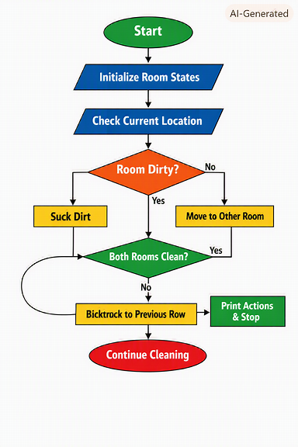

Output:
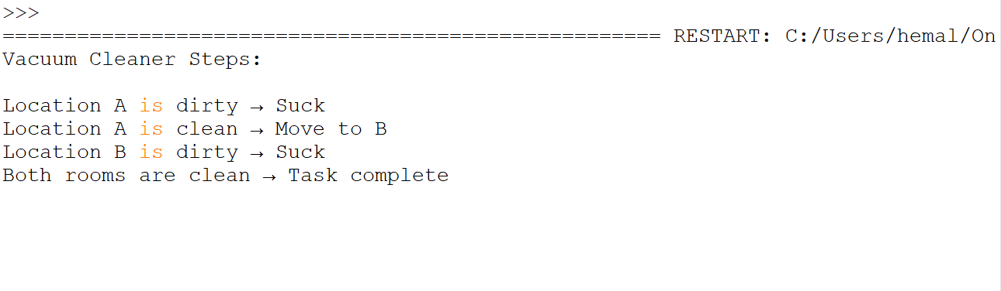

Result:
The Vacuum Cleaner program successfully simulated the cleaning process for two rooms using a reflex agent approach. The agent sensed the environment, identified whether the current room was dirty, and performed the appropriate action — either Suck or Move.
The program displayed each step clearly, showing how the vacuum cleaned both rooms efficiently. Once both rooms were clean, the agent terminated its operation, confirming that the environment was fully cleaned.
Thus, the Vacuum Cleaner Problem was successfully implemented using the Reflex Agent model in Python.

